FOREST COMBUSTION RECOGNITION
Using Artiﬁcial Intelligence
Smart Bridge-Remote Internship Program

Developed by: Sanjana Rajesh Revankar, C V Yashaswini, Neha S, Spandana K, N S Shravani

1 . INTRODUCTION
With climate change rising temperatures, wildfires have been a growing concern for many countries around the world. Fire related disasters are the most common type of emergency situation which requires thorough analysis of the situation required for a quick and precise response. Increase in forest fires in forest areas around the world has resulted in an increased motivation for developing fire warning systems for the early detection of wildfires. Many commercial fire detection sensor systems exist, but all of them are difficult to apply at large open spaces like forests because of their response delay, necessary maintenance needed, high cost, and other problems.
With the rapid development of digital camera technology and image processing technology, the flame detection method based on computer vision systems has gradually replaced the traditional method and has become an important trend. Due to the complex background and large space of the forest fire image, certain difficulties are brought to the forest fire identification process, especially in the feature selection process, there are often some blind operations.
Applying the Convolutional Neural Networks (CNN) technology to image recognition can avoid blindness and randomness to a large extent in the feature extraction process, and theoretically extract deeper features, which can greatly improve the accuracy of flame image recognition. CNN technology has been applied to fire image recognition by many researchers.Therefore, our approach is to employ state-of-the-art CNNs to distinguish between images of the forest with fire and without fire and build an accurate fire detection system. To make these models more robust, we use a custom-made image dataset containing images with numerous scenarios.

1.1 Overview:
Nowadays, Forest ﬁres prediction combines weather factors, rain, dryness of ﬂammable items, types of ﬂammable items, and ignition sources to analyze and predict the combustion risks of ﬂammable items in the forest.
Our project is based on AI for identiﬁcation of “ FOREST COMBUSTION”.The main aim is to predict and detect forest ﬁres in sparsely populated forest areas using ground based methods like Cameras and Video based approach.
Forest ﬁre prediction has developed rapidly in various countries in the world since its inception in the 1920s. Taiwan's forestry department currently uses the study results of Hsiao (2003). Hsiao's study used a given day's highest temperature, temperature variation, accumulated period without rainfall, and drought index as weather factors to derive forest ﬁre incident in a logistical regression model, and built a forest ﬁre recognition probability model and convolution neural network. Hsiao also considered space and many various weather factors, used GIS systems to conduct temperature and rainfall space-me estimates, and estimated forest ﬁre hazard range predictions for forest in Taiwan on a given data.

1.2 Purpose:
Forest ﬁres are a major environmental issue, creating economic and ecological damage while endangering human lives. There are typically about 100,000 wildﬁres in the United state every year. Over 9 million acres of land have been destroyed due to treacherous wildﬁres.Our project ensures to identify ﬁre affected areas and also provides remedial measures for forest fires (all about detecting). Our aim from the project is to make use of pandas, numpy libraries from python to extract the libraries for machine learning for the forest ﬁre recognition. Secondly, to learn how to build models using Image Data Generator hyper tune the forest with and without ﬁre images using Convolution neural network(CNN) machine learning algorithm. And in the end, to predict whether the image is of forest or the forest fire using video analysis techniques of combining the predictions from machine learning algorithms and giving the alert message to the email address.

- LITERATURE SURVEY
Data mining is the process of analyzing data from diﬀerent perspectives and extracting useful knowledge from it. It is the core of the knowledge discovery process. The various steps involved in extracting knowledge from raw data as depicted in ﬁgures. Diﬀerent data mining techniques include classiﬁcation, clustering, association rule mining, prediction and sequential patterns, neural networks, regression, CNN, RNN etc. Convolutional neural networks with many layers have recently been shown to achieve excellent results on many high-level tasks such as image classification, object detection and more recently also semantic segmentation. This approach frequently employs Decision tree based classiﬁcation Algorithms. In classiﬁcation, a training set is used to build the model as the classiﬁer which can classify the data images/items into its appropriate classes. A test set is used to validate the model.

  - Existing problem
Forest ﬁres are a major environmental issue, creating economic and ecological damage while endangering human lives. There are typically about 100,000 wildﬁres in the United States every year. Over 9 million acres of land have been destroyed due to treacherous wildﬁres. It is diﬃcult to predict and detect Forest Fire in a sparsely populated forest area and it is more diﬃcult if the prediction is done using ground based methods like Camera or Video Based approach. Satellites can be an important source of data prior to and also during the Fire due to its reliability and eﬃciency.

2.2 Proposed Solution
Convolution Neural Network based model “Forest Combustion Recognition” incorporating an alert system. The model can detect the fire in the forest in live video streaming and sends an alert email via Simple Transfer Protocol to avoid further damage. This basically composed of two modules namely:
Forest Fire Detection - Detects the fire in the forest
Fire Management - Triggers an alert message as soon as fire is detected that might be initiation of fire.

3. THEORETICAL ANALYSIS

3.1. Block Diagram
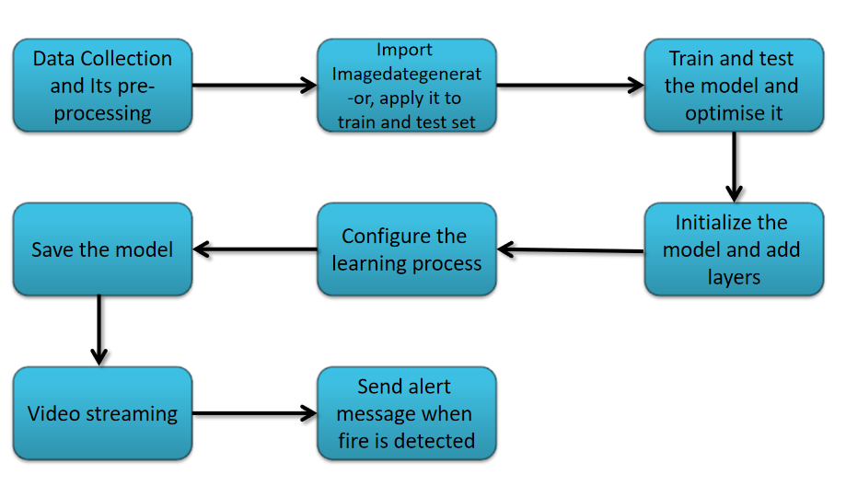
Fig 1: Block Diagram

3.2. Hardware/Software Designing

- Jupyter Notebook Environment.
- Machine Learning Algorithms
- Tensorflow and keras modules
- Python (Numpy, ImageDataGenerator, Model building, CNN layers,Video preprocessing algorithms).
- Camera for video streaming.

4. EXPERIMENTAL INVESTIGATION
We used Python language for building this project. Python is an interpreted and high level programming language. The model is based on convolutional neural networks, which can detect the fire in the forest using opencv video streaming.
The dataset used for training the model contains both the image of forest with fire and regular forest. The dataset is divided into train set and test set with further containing two sub folders of fire and no fire images. The images in train and test are distributed randomly in 80% and 20% of the whole dataset respectively. The data is pre-processed using ImageDataGenarator and the model is built on neural network layers of tensorflow keras module. The model has run upto 10 epochs to get accurate predictions. Implemented video streaming and processing using opencv module and email alerting that successfully detects the fire in either image or live video streaming and can send an alert email if the model detects fire.
Some of the images from the dataset:
Forest Without Fire

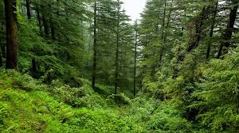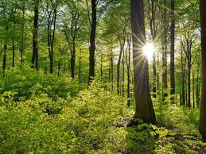
Forest With Fire

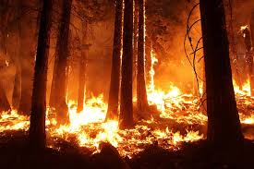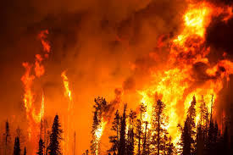

5. FLOW CHART

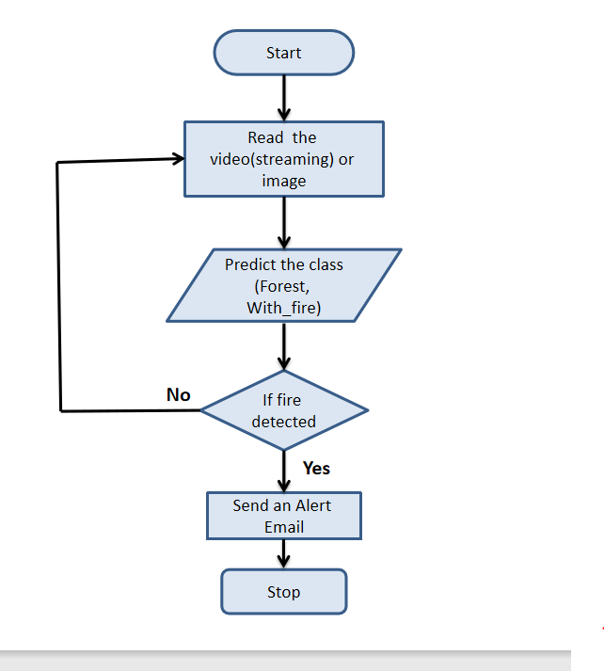
Fig 2: Flowchat of Forest Combustion Recognition Model

6. RESULT

Our model was able to detect both the images of forest that are with fire and without fire accurately. The model predicted the images with about 97% of accuracy. Other than test data, we even provided the model with fire and non fire forest images which were randomly collected over the internet and the model detected the class with great accuracy. We even implemented live video streaming for the prediction, where it can be used to continuously stream over forest in case it detects the fire then the model can alert the fire management systems. In our local machine we used a webcam for video streaming, we collected images of forest and forest with fire and showed them through the webcam and the model detected accurately and sent an alert email to the mail id we provided to it. This indicates that, our model has successfully achieved a state-of-the-art in forest fire detection task using CNN with great performance.

Predictions:

- Predicts class as Forest and prints “no danger”

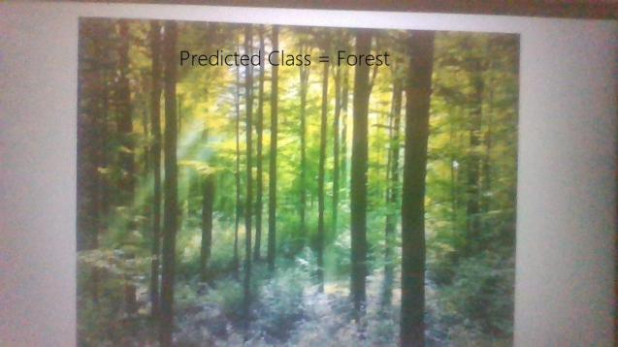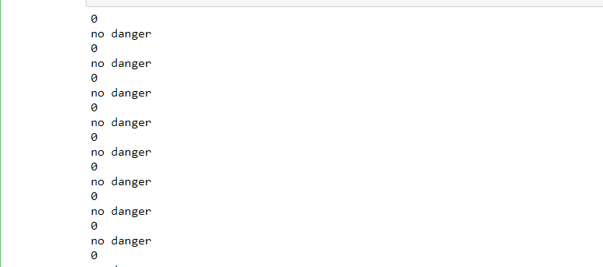

- Predicts class as With Fire , prints “Fire Detected” and sends an alert mail.

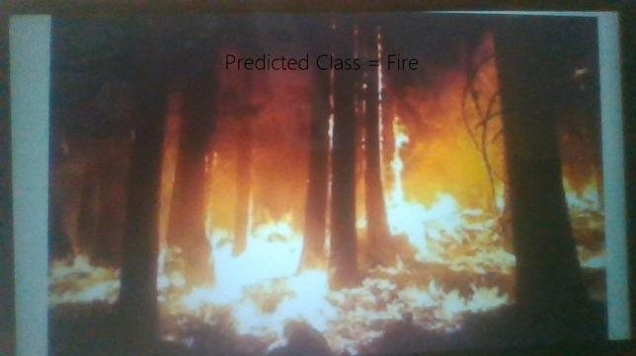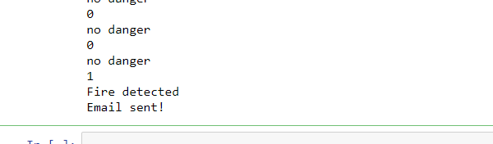

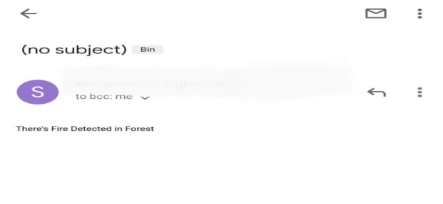 Alert Mail is sent.

- ADVANTAGES & DISADVANTAGES

Advantages:

- High performance.
- Easy to implement.
- Work efficiently.
- Less expensive when compared to existing large machines.
- Detects the fire as soon as possible which in turn can reduce the impact of fire.
- Reduces significant economic impact on government.
- Reduces the pollution caused by fire if the model detects it at the initial stages.

Disadvantages:

- Determining climate conditions, daily temperature differences, Seasonal normal temperature values etc.. are problematic.
- Camera must be maintained well because it is the main compound for this model to work on.
- Users can make mistakes while typing a message format.
- It might even detect some small fire made by any man for his purpose and sending an alert mail on this can cause problems.

- APPLICATIONS

- Model can be used for Health, Military, Commercial applications to detect fire.
- Can be used as Multi-hop communication for large forest
- And also used for Environmental applications like Habitat Monitoring and Forest fire detection.

- CONCLUSION

The model predicted the images with about 97% of accuracy. Other than test data, we even provided the model with fire and non fire forest images which were randomly collected over the internet and the model detected the class with great accuracy. We even implemented live video streaming for the prediction, where it can be used to continuously stream over forest in case it detects the fire then the model can alert the fire management systems. The results show that the proposed model achieves good detection rates. These results indicate that the proposed method is accurate and can be used in automatic forest fire-alarm systems. In future, we will be updating the system with additional features like increase the range of sensing of the sensor, monitoring the count of animals present in the forest and can be prevented from being endangered.

- BIBLIOGRAPHY

OpenCV for video processing:

https://opencv-python-tutroals.readthedocs.io/en/latest/py_tutorials/py_gui/py_video_display/py_video_display.html

Alert Message System:

https://www.tutorialspoint.com/python/python_sending_email.html

